Formalities for Foreign Teachers from Mainland China
- Work permit
1. Transferring from Other Institutions
The applicant should start the new work permit application 30 days before the resident permit expire. Check list:
1)Face phot，jpg,40k-120k;
2)Passport information page, residence permit page;
3)Employment Contract with NUIST in Chinese；
4)Highest degree diploma；
5)Medical report issued by recognized hospital within 6 months ；
6)Cancellation letter for work permit and recommendation letter;
7)Filled information form（Annex 4）
2. Holding non-work type visa and employed by NUIST
Applicable to professor/associate professor/post doctors. Check list:
1)Face photo, jpg，40-120k；
2)Passport information page;
3)Chinese Contract;
4)Visa page and entry stamp page;
5)Medical report issued by designated hospital within 6 months;
6)Highest degree certificate;
7)Reference letter;
8)No criminal record commitment(Annex 5);
9)CV
- Police registration within 24 hours
Register by Wetchat according to the instruction with the help of assistant:
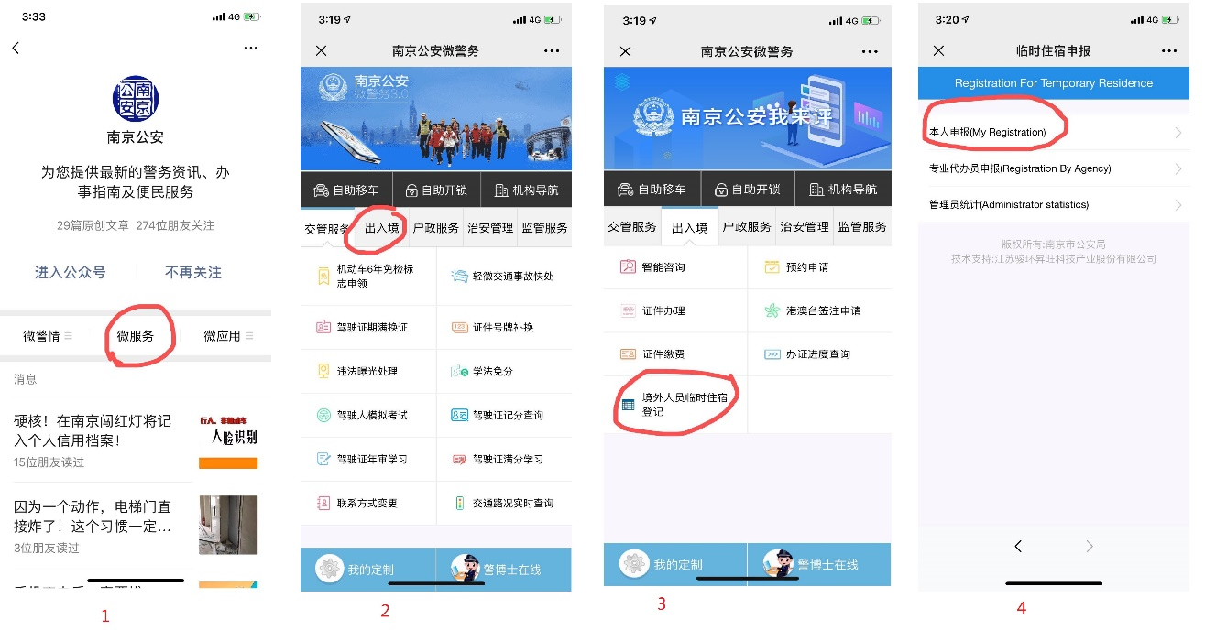
- Residence permit
Address: Smart Police Service Center inside Taifeng Road Metro Station (Line S8), near Exit 1; Time: 8:00am-8:00pm, Monday-Sunday
Check list:
- School letter;
- Work permit information page stamped by school;
- Application form;
- Passport original and copies of information page, visa page, and entry stamp page;
- Work permit card (original and copy);
- Image photo(size 2 with white background, within 6 months);
- Accommodation registration form from local police station;
8. Medical check report (only for new teachers);
9. Accompanying family members’ document(if available)

