Recruitment Formalities for Foreign Teachers from Abroad

Before Entry
- Confirmation Letter for High Level Foreign Talents
Applicable to high level foreign talents with internationally recognized professional achievements who will apply for R visa.
Checklist:
- Passport information page;
- Signed and Stamped Contract or Invitation letter from NUIST;
- Face photo in white background( jpg format,40-120k);
- Professional Achievement Certificate （Original and Chinese translation）;
- Filled Application Form（Annex 1）
- Notification Letter of Foreigner’ Work Perm
Applicable to foreign teachers employed as / professor/associate professor/post doctor/lecturer /language teacher who will apply for Z visa.
Checklist(Annex 2)：
- Passport information page;
- Signed and Stamped Contract in Chinese;
- Face photo in white back ground(jpg format, 40-120k);
- Highest degree diploma(shall be convicted by Chinese Embassy, both original and Chinese translation are necessary);
- Certificate of no criminal conviction(shall be convicted by Chinese Embassy, both original and Chinese translation are necessary ; professor/associate professor/post doctor can make commitment as Annex 5);
- Medical report done within 6 months(Annex 3);
- Filled information form(Annex 4);
- Documents of accompanying family members(relationship certificate shall be verified by Chinese Embassy)

After Entry
- Police registration within 24 hours
Register by Wetchat according to the instruction with the help of assistant: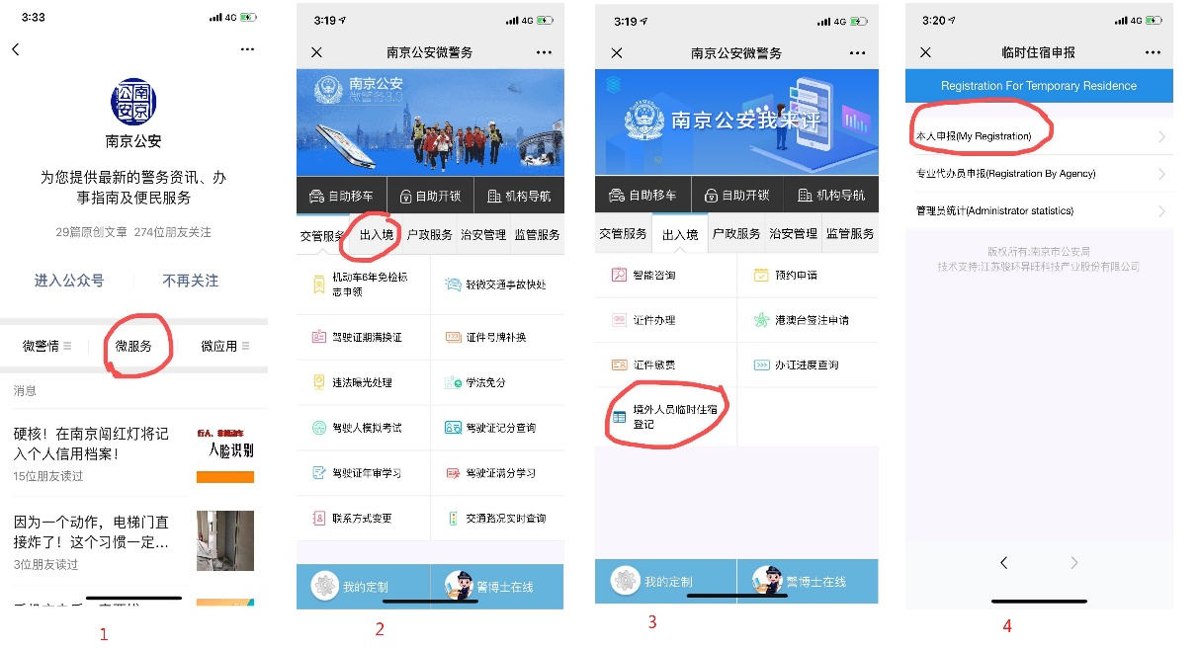
- Medical report verification
Make appointment with Jiangsu International Travel Health Center on Wechat(江苏国际旅行卫生保健中心) and go to the recognized hospital at supposed time in the following address:
No. 39, Chuangzhi Road, Nanjing
Tel:025-52345700
If your report from abroad meets the requirements, it will be changed to a new report; If not you need to do medical check again. It will take 4 working days to get the new report.
- Work permit
Check list:
- Application form；
- Passport information page, visa page, entry page;
- Employment Contract in Chinese；
- New medical report;
All originals of documents used in the process before entry need to be checked.
- Residence permit
Address: Smart Police Service Center inside Taifeng Road Metro Station (Line S8), near Exit 1; Time: 8:00am-8:00pm, Monday-Sunday
Check list:
- School letter;
- Work permit information page stamped by school;
- Application form;
- Passport original and copies of information page, visa page, and entry stamp page;
- Work permit card (original and copy);
- Image photo(size 2 with white background, within 6 months);
- Accommodation registration form from local police station;
8. Medical check report (only for new teachers);
9. Accompanying family members’ document(if available)

